**Simulation/Verification Of L1 Cache Controller**

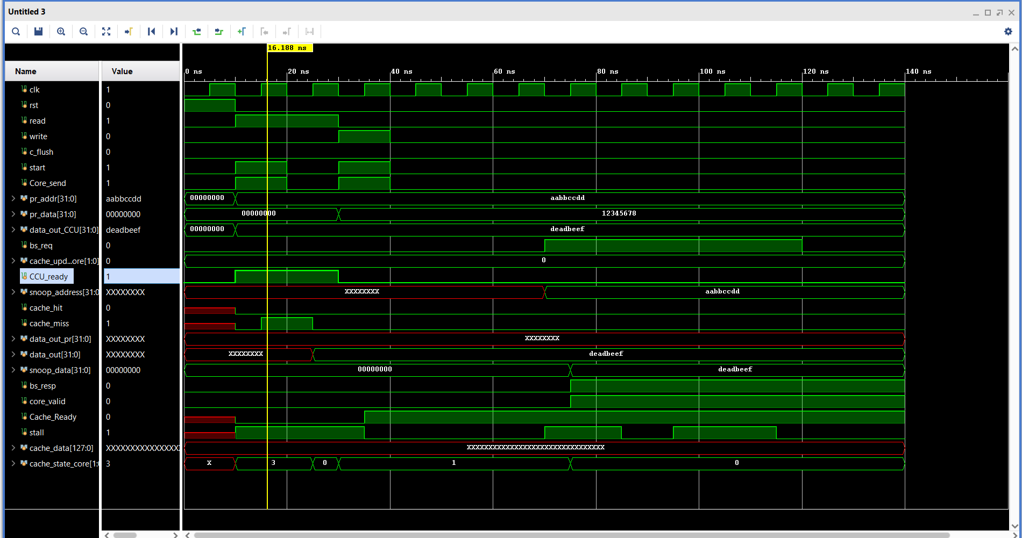

All tests passed!